**TITLE**

**DOMAIN INTRODUCTION:**

**Image processing** is a method to convert an image into digital form and perform some operations on it, in order to get an enhanced image or to extract some useful information from it. It is a type of signal dispensation in which input is image, like video frame or photograph and output may be image or characteristics associated with that image. Usually **Image Processing** system includes treating images as two dimensional signals while applying already set signal processing methods to them.

It is among rapidly growing technologies today, with its applications in various aspects of a business. Image Processing forms core research area within engineering and computer science disciplines too.

*Image processing basically includes the following three steps*.

·            Importing the image with optical scanner or by digital photography.

·            Analyzing and manipulating the image which includes data compression and image enhancement and spotting patterns that are not to human eyes like satellite photographs.

·            Output is the last stage in which result can be altered image or report that is based on image analysis.

**Purpose of Image processing**

The purpose of image processing is divided into 5 groups. They are:

1.      Visualization - Observe the objects that are not visible.

2.      Image sharpening and restoration - To create a better image.

3.      Image retrieval - Seek for the image of interest.

4.      Measurement of pattern – Measures various objects in an image.

5.      Image Recognition – Distinguish the objects in an image.

**Types**

The two types of **methods used for Image Processing** are **Analog and Digital** Image Processing. Analog or visual techniques of image processing can be used for the hard copies like printouts and photographs. Image analysts use various fundamentals of interpretation while using these visual techniques. The image processing is not just confined to area that has to be studied but on knowledge of analyst. Association is another important tool in image processing through visual techniques. So analysts apply a combination of personal knowledge and collateral data to image processing.

Digital Processing techniques help in manipulation of the digital images by using computers. As raw data from imaging sensors from satellite platform contains deficiencies. To get over such flaws and to get originality of information, it has to undergo various phases of processing. The three general phases that all types of data have to undergo while using digital technique are Pre- processing, enhancement and display, information extraction.

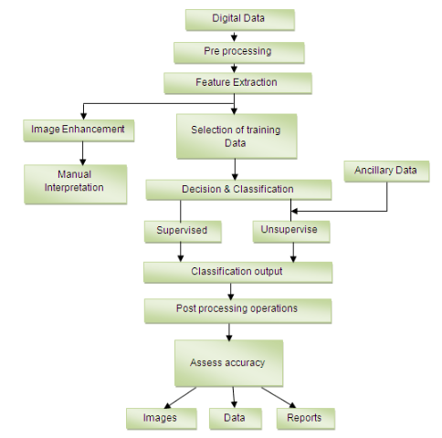

**MACHINE LEARNING:**

“Optimizing a performance criterion using example data and past experience”, said by E. Alpaydin, gives an easy but faithful description about machine learning. In machine learning, data plays an indispensable role, and the learning algorithm is used to discover and learn knowledge or properties from the data. The quality or quantity of the dataset will affect the learning and prediction performance. The textbook (have not been published yet) written by Professor Hsuan-Tien Lin, the machine learning course instructor in National Taiwan University (NTU), is also titled as “Learning from Data”, which emphasizes the importance of data in machine learning. Fig. 1 shows an example of two-class dataset.

Training Set and Test Set In machine learning, an unknown universal dataset is assumed to exist, which contains all the possible data pairs as well as their probability distribution of appearance in the real world. While in real applications, what we observed is only a subset of the universal dataset due to the lack of memory or some other unavoidable reasons. This acquired dataset is called the training set (training data) and used to learn the properties and knowledge of the universal dataset. In general, vectors in the training set are assumed independently and identically sampled (i.i.d) from the universal dataset. In machine learning, what we desire is that these learned properties can not only explain the training set, but also be used to predict unseen samples or future events. In order to examine the performance of learning, another dataset may be reserved for testing, called the test set or test data. For example, before final exams, the teacher may give students several questions for practice (training set), and the way he judges the performances of students is to examine them with another problem set (test set).

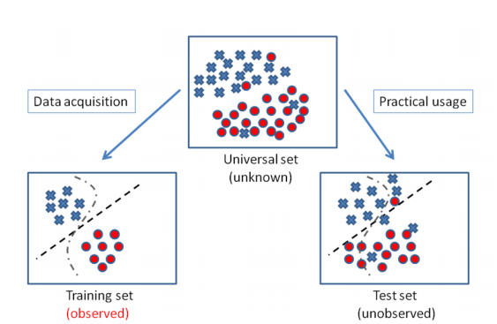

**ABSTRACT:**

The human face is an important part of an individual’s body and plays an important role in knowing the individual’s mood. The face is where a human expresses all his basic emotions.

In existing system, we examine the criminal mental disorders manually by assessing them but which has many disadvantages like we cannot predict any accurate solutions based on the assessment score because we might be not sure what kind of emotions the human user would be all time. To overcome this problem and suggest an effective solution for Criminal rehabilitation, we propose a hybrid architecture invoking facial based emotion sequence, PEN test, IQ test. By consistent monitoring of a human’s emotion and subjecting to PEN and IQ test, the human’s mental state is routed. Combination of above three techniques provides promising results for Criminal rehabilitation and self-control.

**INTRODUCTION:**

Facial expressions can be considered not only as the most natural form of displaying human emotions but also as a key non-verbal communication technique. If efficient methods can be brought about to automatically recognize these facial expressions, striking improvements can be achieved in the area of human computer interaction. Research in facial emotion recognition has being carried out in hope of attaining these enhancements. In fact, there exist other applications which can benefit from automatic facial emotion recognition. Artificial Intelligence has long relied on the area of facial emotion recognition to gain intelligence on how to model human emotions convincingly in robots. Recent improvements in this area have encouraged the researchers to extend the applicability of facial emotion recognition to areas like chat room avatars and video conferencing avatars. The ability to recognize emotions can be valuable in face recognition applications as well. Suspect detection systems and intelligence improvement systems meant for children with brain development disorders are some other beneficiaries.

The processing of emotional facial expressions is modulated by personality; for example, neuroticism, a dimension of the five-factor model of personality has been found to play a role in this regard. Neuroticism is characterized by the tendency to be anxious, nervous, and hostile. Neuroticism is also considered to be a risk predictor for depression.

Cognitive and executive functions are often impaired in different clinical disorders, such as dementia, attention deﬁcit hyperactivity disorder, schizophrenia and obsessive compulsive disorder. In schizophrenia, cognitive impairments are often found in multiple areas, including visual information processing; attention; working memory; short-term memory and learning; executive functioning; speed of processing; reasoning and problem solving; context processing and social perception and cognition. The impairment of executive functions called “dysexecutive syndrome”, are common in neurological patients and are related to brain dysfunction speciﬁcally in the prefrontal cortex. Individuals who have an impairment of executive functions show problems of starting and stopping activities, a difﬁculty in mental and behavioral shifts, an increased distractibility and difﬁculties in learning new tasks. The executive functions, deﬁned as higher order cognitive functions needed for performing complex tasks, are often impaired also in patients with Obsessive Compulsive Disorder (OCD) which are characterized by the impairment of several skills such as attention, planning, problem-solving and behavioral control. Further, OCD is often associated with impairments of visuospatial skills, and of memory functioning, including visual, verbal, and numerical. Therefore, no single proﬁle of cognitive deﬁcits has been found to characterize all patients; the majority have impaired ability in at least one area of functioning and a standardized platform for assessing neurocognitive functioning is an important aspect of comprehensive treatment and research for this and other conditions.

**EXISTING SYSTEM:**

Existing systems are highly complex in terms of time and storage for recognizing user behavior. Existing system focus on only manual assessment which takes time and doesn’t provide promising results as the user emotions keeps varying based on personal, situational problems. Existing system doesn’t invoke biometric based emotion recognition of the users. Existing system doesn’t focus on user facial expression with cycometric test based automatic individual criminal behavior prediction.

**PROPOSED SYSTEM:**

Mental Illness has a profound impact on people’s functioning, health and quality of life. Detecting early warnings of depression or any other mental illness is challenging. The proposed system provides a hybrid architecture invoking facial based emotion sequence, PEN test, IQ test. By consistent monitoring of a human’s emotion and subjecting to PEN and IQ test, the human’s mental state is routed. Combination of above three techniques provides promising results for Criminal rehabilitation and self-control.

In our proposed system, the emotions are continuously monitored based on which the information for the classification of mental illness of the person is obtained. Further, using the information obtained, it conducts a psychology test to diagnose the severity of the mental condition. It combines these outputs with a psychometric study which consists of an IQ test and a Personality test. The output of the combination of these three parameters are classified to determine the probabilities of criminal potential a person can hold.

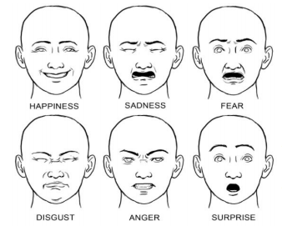

**ARCHITECTURE DIAGRAM:**

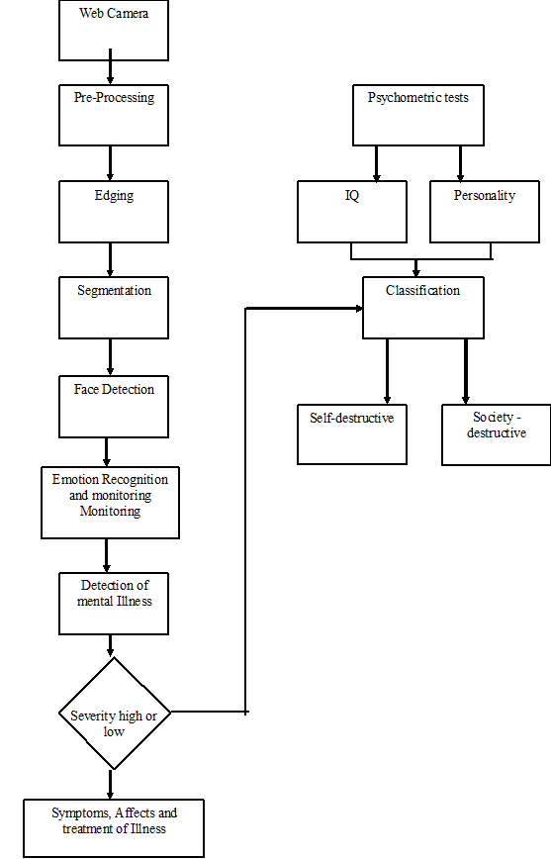

**RELATED WORKS:**

**Polaris Koi• Susanne Uusitalo• Jarno Tuominen**

**Self-Control in Responsibility Enhancement and Criminal Rehabilitation, 2018**

In this paper, we critically examine the promise of improving convicts’ capacity responsibility by neuroenhancements of self-control to see whether the special characteristics of the inmate population make a difference in the analyses. As improving self-control by means of neurointerventions seems plausible, we then ask whether it is or could be a justiﬁed measure in court rulings. We conclude that, even if there are cases in which neurointerventions were warranted in the context of the stated goals of the criminal court, i.e., decreasing recidivism and rehabilitating the offenders to the society, due to the range of individual variability in the constitution of self-control, the prescription of speciﬁc neurointerventions of self-control falls outside the scope of legitimate court rulings.

**The Knowledge Base for Computer-Aided Diagnosis of Mental Disorders Based on Psychometric Tests, 2014**

**Olga Mich, Andrzej Burda, Krzysztof Pancerz and Jerzy Gomuła**

The knowledge base is a key element of many decision support systems. In the paper, we describe, the knowledge base implemented in the Copernicus system - a tool for computer-aided diagnosis of mental disorders based on data coming from psychometric tests, in the current version, coming from the Minnesota Multiphasic Personality Inventory (MMPI) test. This tool uses a variety of classiﬁcation ways for differential inter proﬁle diagnosis. Therefore, the knowledge base embodied in the tool is of different character. The special attention is focused on new elements added in the last version of the Copernicus system.

**Psychometric Assessment Using Classic Neuropsychological and Virtual Reality Based Test: A Study in Obsessive-Compulsive Disorder (OCD) and Schizophrenic Patients, 2014**

**Filippo La Paglia, Caterina La Cascia, Pietro Cipresso, Rosalinda Rizzo, Antonio Francomano, Giuseppe Riva, and Daniele La Barbera**

Assessment of neurocognitive functioning is a critical task in clinical settings. In many disorders, cognitive impairment precedes the onset of behavioral symptoms, and cognitive decline is a major factor contributing to functional disability. The purpose of the current study was to evaluate the executive functions by comparing the evaluations obtained using a neuropsychological battery with the one obtained using the virtual reality version of the Multiple Errands Test (V-MET). The study population included three groups: 10 patients affected by Obsessive Compulsive Disorder (OCD); 10 Schizophrenic patients; 10 healthy Controls. The results identiﬁed executive problems in clinical samples.

**Computerized Adaptive Diagnosis and Testing of Mental Health Disorders, 2016**

**Robert D. Gibbons, David J. Weiss, Ellen Frank, and David Kupfer**

In this review we explore recent developments in computerized adaptive diagnostic screening and computerized adaptive testing for the presence and severity of mental health disorders such as depression, anxiety, and mania. The statistical methodology is unique in that it is based on multidimensional litem response theory (severity) and random forests (diagnosis) instead of traditional mental health measurement based on classical test theory (a simple total score) or unidimensional item response theory. We show that the information contained in large item banks consisting of hundreds of symptomitemscanbeefﬁcientlycalibratedusingmultidimensionalitemresponse theory, and the information contained in these large item banks can be precisely extracted using adaptive administration of a small set of items for each individual. In terms of diagnosis, computerized adaptive diagnostic screening can accurately track an hour-long face-to-face clinician diagnostic interview for major depressive disorder (as an example) in less than a minute using an average of four questions with unprecedented high sensitivity and speciﬁcity.

**MODULE DESCRIPTION:**

1. **Facial Expression Recognition:**

The input image to the system can be captured using a web cam or can be acquired from the hard disk. This image undergoes image enhancement, where tone mapping is applied to images with low contrast to restore the original contrast of the image.

**Binarization :**

All RGB and gray scale images are converted into a binary image. This preprocessed image is fed into the face detection block.

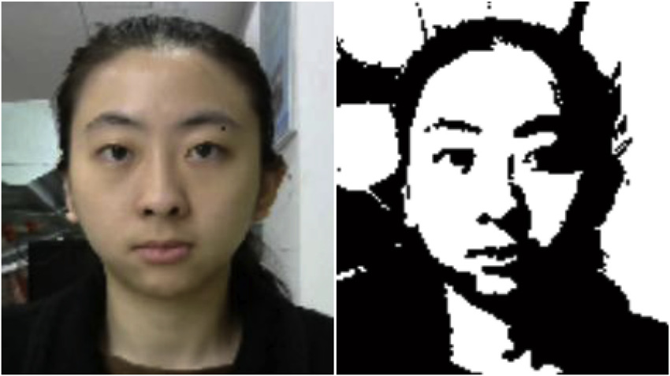

1. **Segmentation:**

* A bounding box is formed over every feature of the face that contributes to an emotion.
* Each bounding box is derived using face coordinates
* These boxes are thus segmented and studied further to derive an emotion.

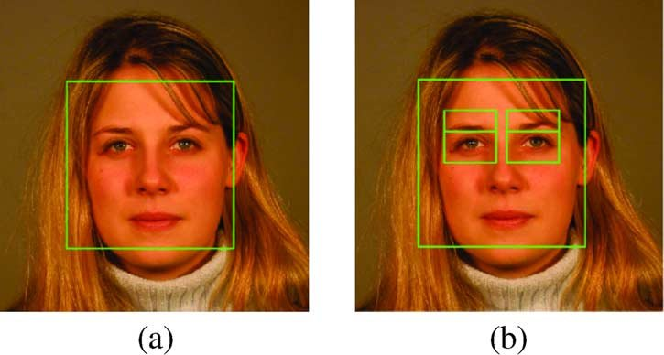

**Feature extraction:**

The facial image obtained from the face detection stage forms an input to the feature extraction stage. To obtain real time performance and to reduce time complexity, for the intent of expression recognition, only eyes and mouth are considered. The combination of two features is adequate to convey emotions accurately.

Finally, a corner ***point detection algorithm*** was used to obtain the required corner points from the feature regions.

**Eye Extraction**

The eyes display strong vertical edges (horizontal transitions) due to its iris and eye white. Thus, the Sobel mask is applied to an image and the horizontal projection of vertical edges can be obtained to determine the Y coordinate of the eyes.

**Eyebrow Extraction**

Two rectangular regions in the edge image which lies directly above each of the eye regions are selected as the eyebrow regions. The edge images of these two areas are obtained for further refinement. Now sobel method was used in obtaining the edge image since it can detect more edges than roberts method. These obtained edge images are then dilated and the holes are filled. The result edge images are used in refining the eyebrow regions.

**Mouth Extraction:**

The top, bottom, right most and left most points of the mouth are been extracted and the centriod of the mouth is calculated.

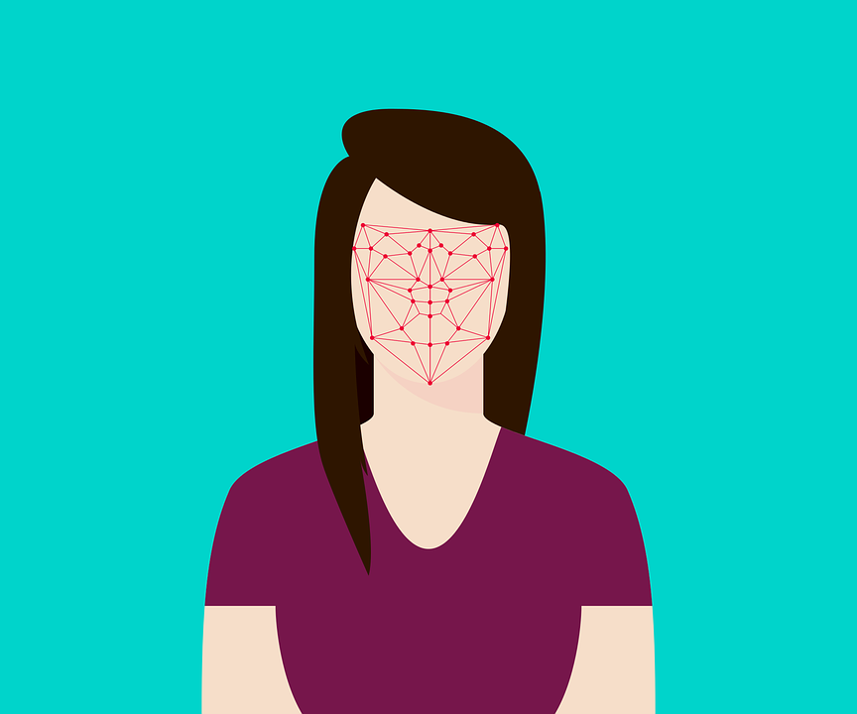

**Facial Emotion Recognition:**

* An emotion matrix is constructed with discrete set of values.
* The rows and columns represent the extent of each motion in the person
* These values set a range that determines the permutations of different emotions.

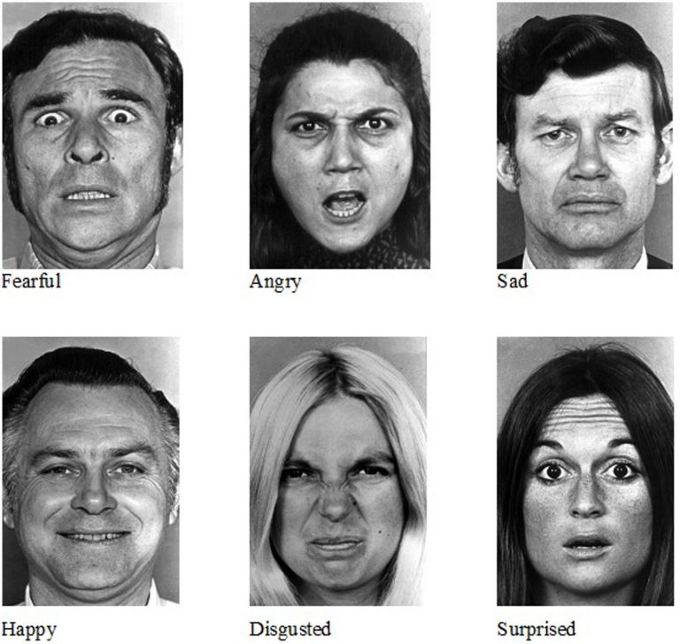 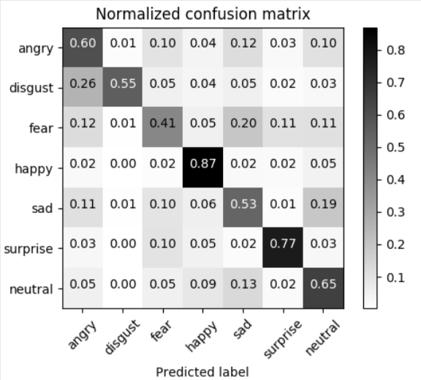

**OPEN CV:**

OpenCV (Open Source Computer Vision) is a library that can be imported in almost all computer languages like python, C, Java etc. It contains optimized image processing tools. Using OpenCV in python boosts its abilities by incorporating numpy (Numerical Python). In image processing, images are dealt as large 3D arrays and numpy serves as a robust tool for numerical array computations. The commands used for installing OpenCV, Matplot library and numpy in raspberry Pi are “sudo apt-get install python-opencv”, “sudo apt-get install pythonmatplotlib”, ”sudo apt-get install python-numpy”. The concept of using Matplot library in python is to plot a graphical representation as well as drawing steps.

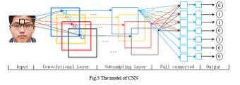

**Mental State Detection**

The emotions recognized are stored in a data frame and monitored over a period of time. Depending on the persistence and repetition of the emotions, mental state of the person is detected. Further a psychology test is taken up to evaluate the severity of the clinical condition.

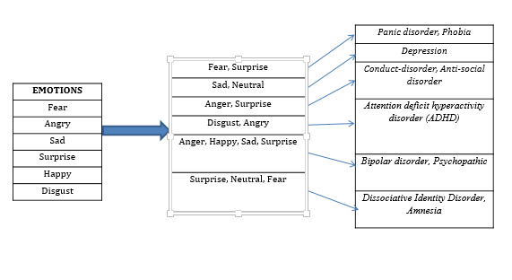

**Evaluation of Psychometrics**

The term psychometrics refers to the design and interpretation of tests that measure psychological values such as aptitude, ability, personality, memory, happiness and intelligence. These tests are designed for, and given in, mental health, education and employment settings.

In this project, we measure the IQ value and the personality traits of the person. Hans Eysenck’s personality test is used to measure personality based on three dimensions psychoticism, extraversion and neuroticism (PEN). Personality disorders like depression, anxiety, dissociation, positive and negative, Agreeableness and Openness, Neuroticism, Psychoticism etc can be detected and preventive measure can be addr4essed at the early stage itself.

**7. Evaluation of Psychometrics**

The term **psychometrics** refers to the design and interpretation of tests that measure psychological values such as aptitude, ability, personality, memory, happiness and intelligence. These tests are designed for, and given in, mental health, education and employment settings.

In this project, we measure the IQ value and the personality traits of the person. Hans Eysenck’s personality test is used to measure personality based on three dimensions psychoticism, extraversion and neuroticism (PEN)

8. **Classification of criminal behavior / mental disorder:**

By considering the output of Psychometrics and mental state as parameters, the probability and the nature of criminal behavior / mental disorder is classified as self-destructive and harmful to the society.

SOFTWARE REQUIREMENTS

   Operating system                   :          Windows 7 Professional.

   Coding Language                   :          Python.

* Backend : SQLite
* Frontend : HTML

HARDWARE REQUIREMENTS

Raspberry Pi Controller

System            :           Pentium IV 2.4 GHz

Hard Disk       :           40 GB

Monitor          :           15 VGA Color

Mouse             :           Logitech

Ram                :           512 MB.

**FEASIBILITY STUDY:**

* A Feasibility Study is the analysis of a problem to determine if it can be solved effectively.
* The results determine whether the solution should be implemented.
* This activity takes place during the project initiation phase and is made before significant expenses are engaged.

**DEFINITION OF FEASIBILITY STUDY:**

* A feasibility study is an evaluation of a proposal designed to determine the difficulty in carrying out a designated task. Generally, a feasibility study precedes technical development and project implementation.
* A feasibility study looks at the viability of an idea with an emphasis on identifying potential problems and attempts to answer one main question: Will the idea work and should you proceed with it?

**FIVE COMMON FACTORS (TELOS)**

1. Technology and system feasibility
2. Economic feasibility
3. Legal feasibility
4. Operational feasibility
5. Schedule feasibility

**TECHNOLOGY AND SYSTEM FEASIBILITY**

The assessment is based on an outline design of system requirements in terms of Input, Processes, Output, Fields, Programs, and Procedures. This can be quantified in terms of volumes of data, trends, frequency of updating, etc. in order to estimate whether the new system will perform adequately or not this means that feasibility is the study of the based in outline.

**ECONOMIC FEASIBILITY**

Economic analysis is the most frequently used method for evaluating the effectiveness of a new system. More commonly known as cost/benefit analysis, the procedure is to determine the benefits and savings that are expected from a candidate system and compare them with costs. If benefits outweigh costs, then the decision is made to design and implement the system. An entrepreneur must accurately weigh the cost versus benefits before taking an action. Time Based.

**LEGAL FEASIBILITY**

Determines whether the proposed system conflicts with legal requirements, e.g. a data processing system must comply with the local Data Protection Acts.

**Operational feasibility**

Is a measure of how well a proposed system solves the problems, and takes advantages of the opportunities identified during scope definition and how it satisfies the requirements identified in the requirements analysis phase of system development.

**Schedule feasibility**

A project will fail if it takes too long to be completed before it is useful. Typically this means estimating how long the system will take to develop, and if it can be completed in a given time period using some methods like payback period. Schedule feasibility is a measure of how reasonable the project timetable is. Given our technical expertise, are the project deadlines reasonable? Some projects are initiated with specific deadlines. You need to determine whether the deadlines are mandatory or desirable.

**SOFTWARE ENVIRONMENT:**

PyCharm is a Python IDE for professional developers created by JetBrains. It provides developers with all the tools they need to increase their coding productivity and also offers them smart code assistance.

With PyCharm, developers are able to improve their code’s quality. The developing tool does this with quality checks, testing aid, intelligent refactoring, and framework support among others. With this, code writers can spend more time with additional lines instead of debugging.

Moreover, PyCharm has a user-definable interface so they are free to customize their tools. On top of that, there are also more than fifty plugins available that developers can utilize to enhance their PyCharm experience.

**PyCharm** is an integrated development environment (IDE) used in computer programming, specifically for the Python language. It is developed by the Czech company JetBrains. It provides code analysis, a graphical debugger, an integrated unit tester, integration with version control systems (VCSes), and supports web development with Django.

PyCharm is a Python IDE with complete set of tools for Python development. In addition, the IDE provides capabilities for professional Web development using the Django framework. Code faster and with more easily in a smart and configurable editor with code completion, snippets, code folding and split windows support.

**Smart Python**

With PyCharm, developers are assisted by an intelligent platform that aids them when it comes to code completions, inspections, error pinpointing, quick fixes, and more. This enables them to bolster their productivity as their codes can be automatically completed. Plus, they do not need to waste time scouring their codes for errors to rectify.

**PyCharm Features**

* **Project Code Navigation -** Instantly navigate from one file to another, from method to its declaration or usages, and through classes hierarchy. Learn keyboard shortcuts to be even more productive
* **Code Analysis -** Take advantage of on-the-fly code syntax, error highlighting, intelligent inspections and one-click quick-fix suggestions to make code better
* **Python Refactoring -** Make project-wide code changes painlessly with rename, extract method/superclass, introduce field/variable/constant, move and pull up/push down refactorings
* **Web Development with Django -** Even more rapid Web development with Django framework backed up with excellent HTML, CSS and JavaScript editors. Also with CoffeeScript, Mako and Jinja2 support
* **Google App Engine Support -** Develop applications for Google App Engine and delegate routine deployment tasks to the IDE. Choose between Python 2.5 or 2.7 runtime
* **Version Control Integration -** Check-in, check-out, view diffs, merge — all in the unified VCS user interface for Mercurial, Subversion, Git, Perforce and other SCMs
* **Graphical Debugger -** Fine-tune Python or Django applications and unit tests using a full-featured debugger with breakpoints, stepping, frames view, watches and evaluate expressions
* **Integrated Unit Testing -** Run a test file, a single test class, a method, or all tests in a folder. Observe results in graphical test runner with execution statistics
* **Customizable & Extensible -** Bundled Textmate, NetBeans, Eclipse & Emacs keyboard schemes, and Vi/Vim emulation plugin

**Features:**

* Coding assistance and [analysis](https://en.wikipedia.org/wiki/Code_analysis), with [code completion](https://en.wikipedia.org/wiki/Autocomplete), syntax and error highlighting, linter integration, and quick fixes
* Project and code navigation: specialized project views, file structure views and quick jumping between files, classes, methods and usages
* Python [refactoring](https://en.wikipedia.org/wiki/Refactoring): including rename, extract method, introduce variable, introduce constant, pull up, push down and others
* Support for web frameworks: [Django](https://en.wikipedia.org/wiki/Django_(web_framework)), [web2py](https://en.wikipedia.org/wiki/Web2py) and [Flask](https://en.wikipedia.org/wiki/Flask_(web_framework))
* Integrated Python [debugger](https://en.wikipedia.org/wiki/Debugger)
* Integrated [unit testing](https://en.wikipedia.org/wiki/Unit_testing), with line-by-line [code coverage](https://en.wikipedia.org/wiki/Code_coverage)
* [Google App Engine](https://en.wikipedia.org/wiki/Google_App_Engine) Python development
* Version control integration: unified user interface for [Mercurial](https://en.wikipedia.org/wiki/Mercurial), [Git](https://en.wikipedia.org/wiki/Git_(software)), [Subversion](https://en.wikipedia.org/wiki/Apache_Subversion), [Perforce](https://en.wikipedia.org/wiki/Perforce) and [CVS](https://en.wikipedia.org/wiki/Concurrent_Versions_System) with changelists and merge.

### **SYSTEM TESTING**

This testing approach document is designed for Information and Technology Services’ upgrades to PeopleSoft. The document contains an overview of the testing activities to be performed when an upgrade or enhancement is made, or a module is added to an existing application. The emphasis is on testing critical business processes, while minimizing the time necessary for testing while also mitigating risks. It’s important to note that reducing the amount of testing done in an upgrade increases the potential for problems after go-live. Management will need to determine how much risk is acceptable on an upgrade by upgrade basis.

System testing is simply testing the system as a whole; it gets all the integrated modules of the various components from the integration testing phase and combines all the different parts into a system which is then tested. Testing is then done on the system as all the parts are now integrated into one system the testing phase will now have to be done on the system to check and remove any errors or bugs.

##### **Unit Testing or Component Testing**

It is the first and the most basic level of Software Testing, in which a single unit (i.e. a smallest testable part of a software) is examined in isolation from the remaining source code. Unit Testing is done to verify whether a unit is functioning properly. In other words, it checks the smallest units of code and proves that the particular unit can work perfectly in isolation. However, one needs to make sure that when these units are combined, they work in a cohesive manner. This directs us to other levels of software testing.

In computer programming, **unit testing** is a software testing method by which individual units of source code, sets of one or more computer program modules together with associated control data, usage procedures, and operating procedures are tested to determine if they are fit for use.[[1]](http://en.wikipedia.org/wiki/Unit_testing#cite_note-kolawa-1) Intuitively, one can view a unit as the smallest testable part of an application. In procedural programming, a unit could be an entire module, but it is more commonly an individual function or procedure. In object-oriented programming, a unit is often an entire interface, such as a class, but could be an individual method. Unit tests are short code fragments created by programmers or occasionally by white box testers during the development process. Ideally, each test case is independent from the others. Substitutes such as method stubs, mock objects, fakes, and test harnesses can be used to assist testing a module in isolation. Unit tests are typically written and run by software developers to ensure that code meets its design and behaves as intended.

**CONCLUSION:**

It is essential to get accurate and reliable identification of stress and it requires a valid analysis and experimental methodology framework. The main contribution of the project is developing an experimental model for successfully identifying stress at multiple levels. Our research suggest facial emotion based system along with psychiatric tests with reliably to detect stress. However, to quantify stress into different levels it requires further analysis and validation.

**Future Work**

• Testing on real time data by applying in hospitals.

• To help doctors, counsellors, therapists to identify and detect stress in patients using the framework

• To relive working professionals of stress by identifying on daily basis.

**REFERENCE:**

Alschuler, A.W. (2003). The Changing Purposes of Criminal Punishment: A Retrospective on the Last Century and Some Thoughts about the Next. University of Chicago Law Review 70(1): 1–22.

Barkley, R.A. (1997). ADHD and the Nature of Self-Control. New York: The Guilford Press.

Baroni, A., & Castellanos, F.X. (2015). Stimulants, cognitions and ADHD. Current Opinion in Behavioral Sciences 4: 109–114.

Baumeister, R.F., & Exline, J.J. (1999). Virtue, Personality and Social Relations: Self-Control as the Moral Muscle. Journal of Personality 67(6): 1165–1194.

Beaver, K.M., DeLisi, M., Vaughn, M.G., & Wright, J.P. (2010). The Intersection of Genes and Neuropsychological Deﬁcits in the Prediction of Adolescent Delinquency and Low Self-Control. International Journal of Offender Therapy and Comparative Criminology 54(1): 22–42.

Berman, M.G., Yourganov, G., Askren, M.K., Ayduk, O., Case, B.J., Gotlib, I.H., Kross, E., McIntosh, A.R., Strother, S., Wilson, N.L., Zayas, V., Mischel, W., Shoda, Y., & Jonides, J. (2013). Dimensionality of brain networks linked to life-long individual differences in self-control. Nature Communications 4(1373): 1–7. doi:10.1038/ncomms2374.

Burt, C.H., Simons, R.L., & Simons, L.G. (2006). A Longitudinal Test of the Effects of Parenting and the Stability of Self-Control: Negative Evidence for the General Theory of Crime. Criminology 44 (2): 353–396.

Caplan, A.L. (2006). Ethical issues surrounding forced, mandated, or coerced treatment. Journal of Substance Abuse Treatment 31(2): 117–120.

**Appendices**

**CODING**

**SCREENSHOT**